***Web Programming***

***OR***

***Internet Technologies and E Commerce***

***Project documentation Template***

**Web Site Planning**

Document the web site’s organization and the page design begins with creating a plan.

Examples:

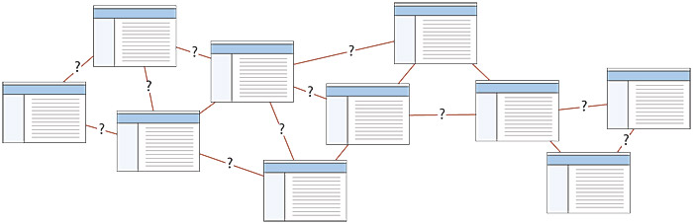

OR

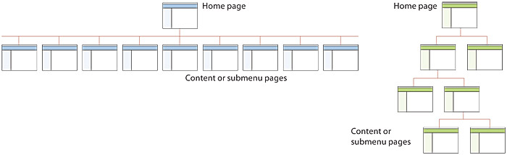

* *Web site’s goals or objectives*
* *Users of the Web site*
* *Web technologies used*
* *Content owners and authors*
* *Information on the Web site*

**Web Site Analysis**

1. Tasks users need to complete
2. processes required to support Web site

**Web Page Design and Development**

* *Layout of each page , forms etc*
* *Snapshot of Database*
* *Add code in appendix*

**Web Site Testing**

* *Show features of website*